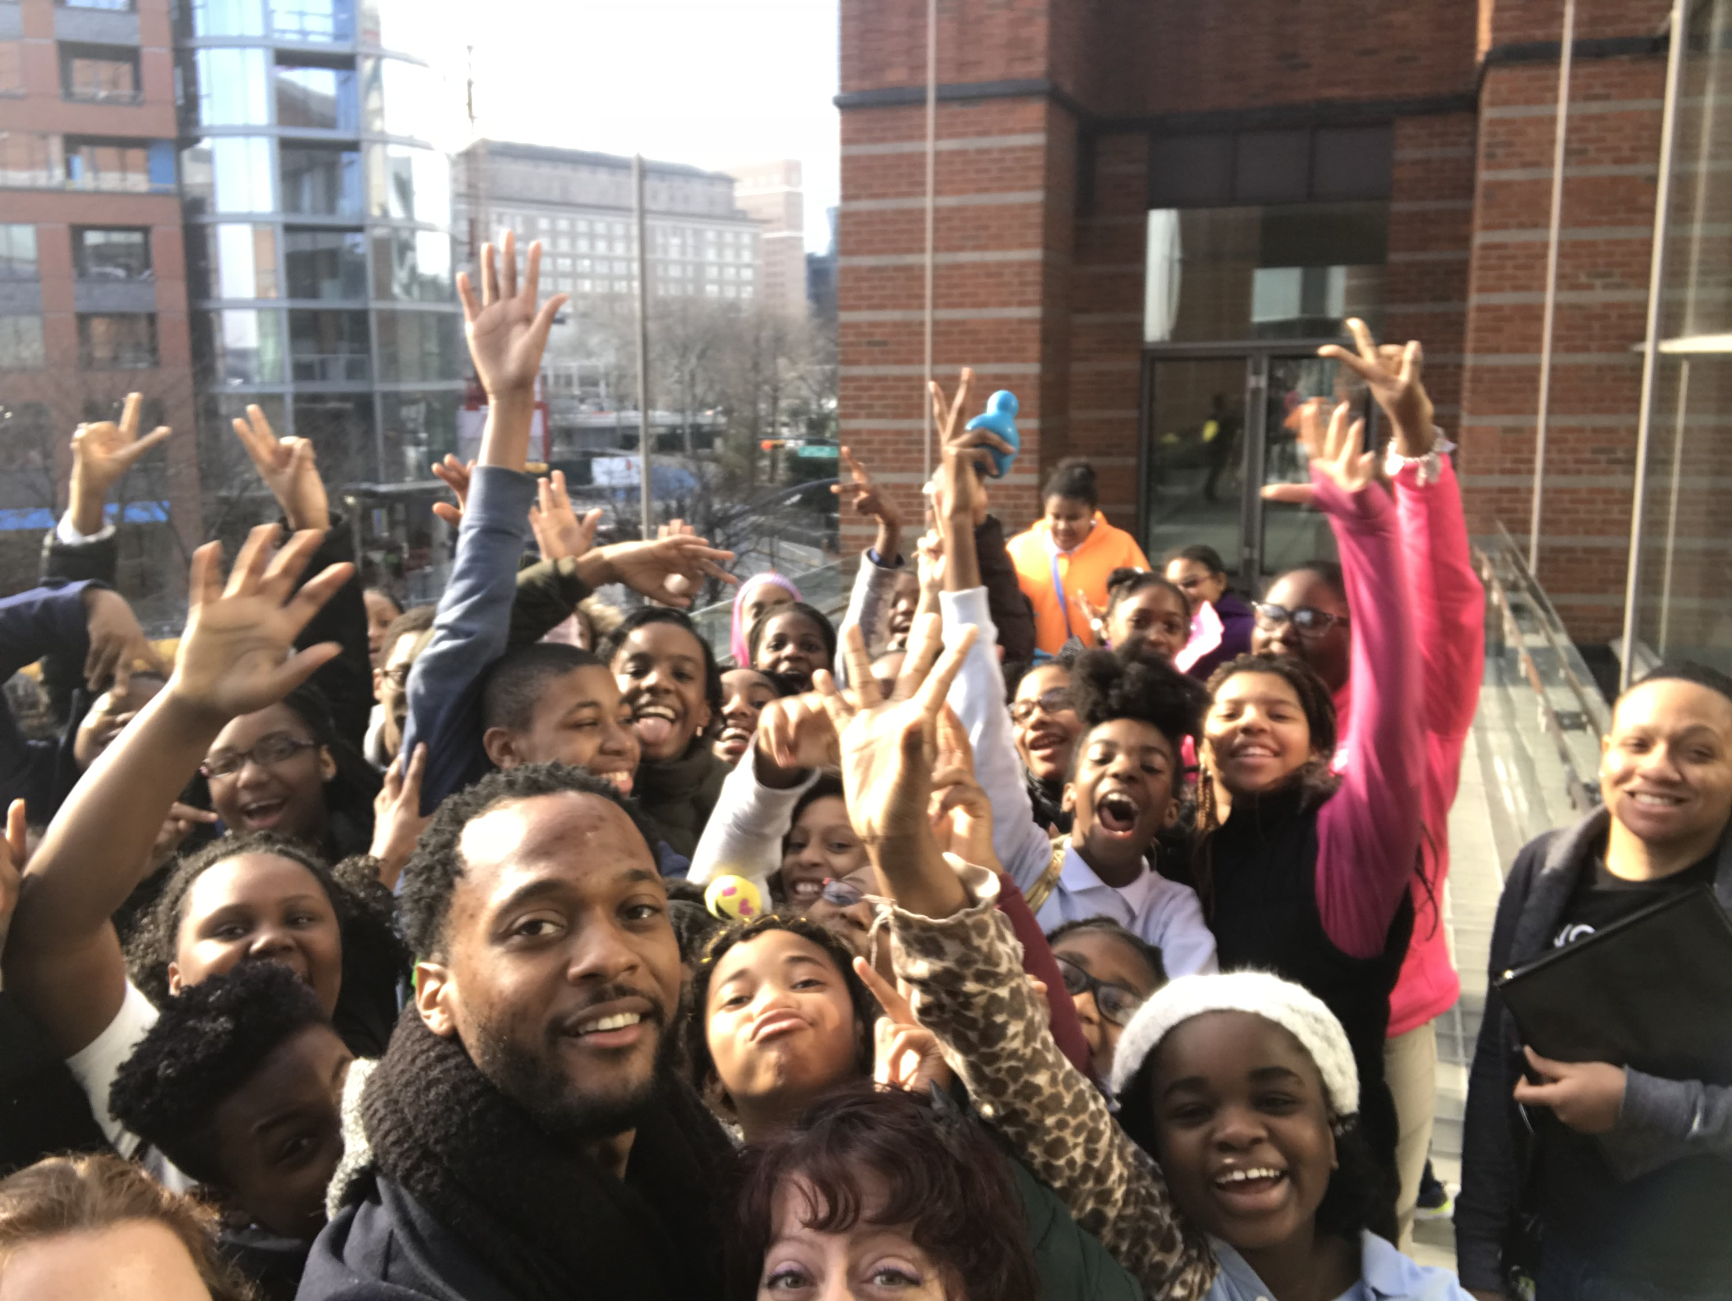
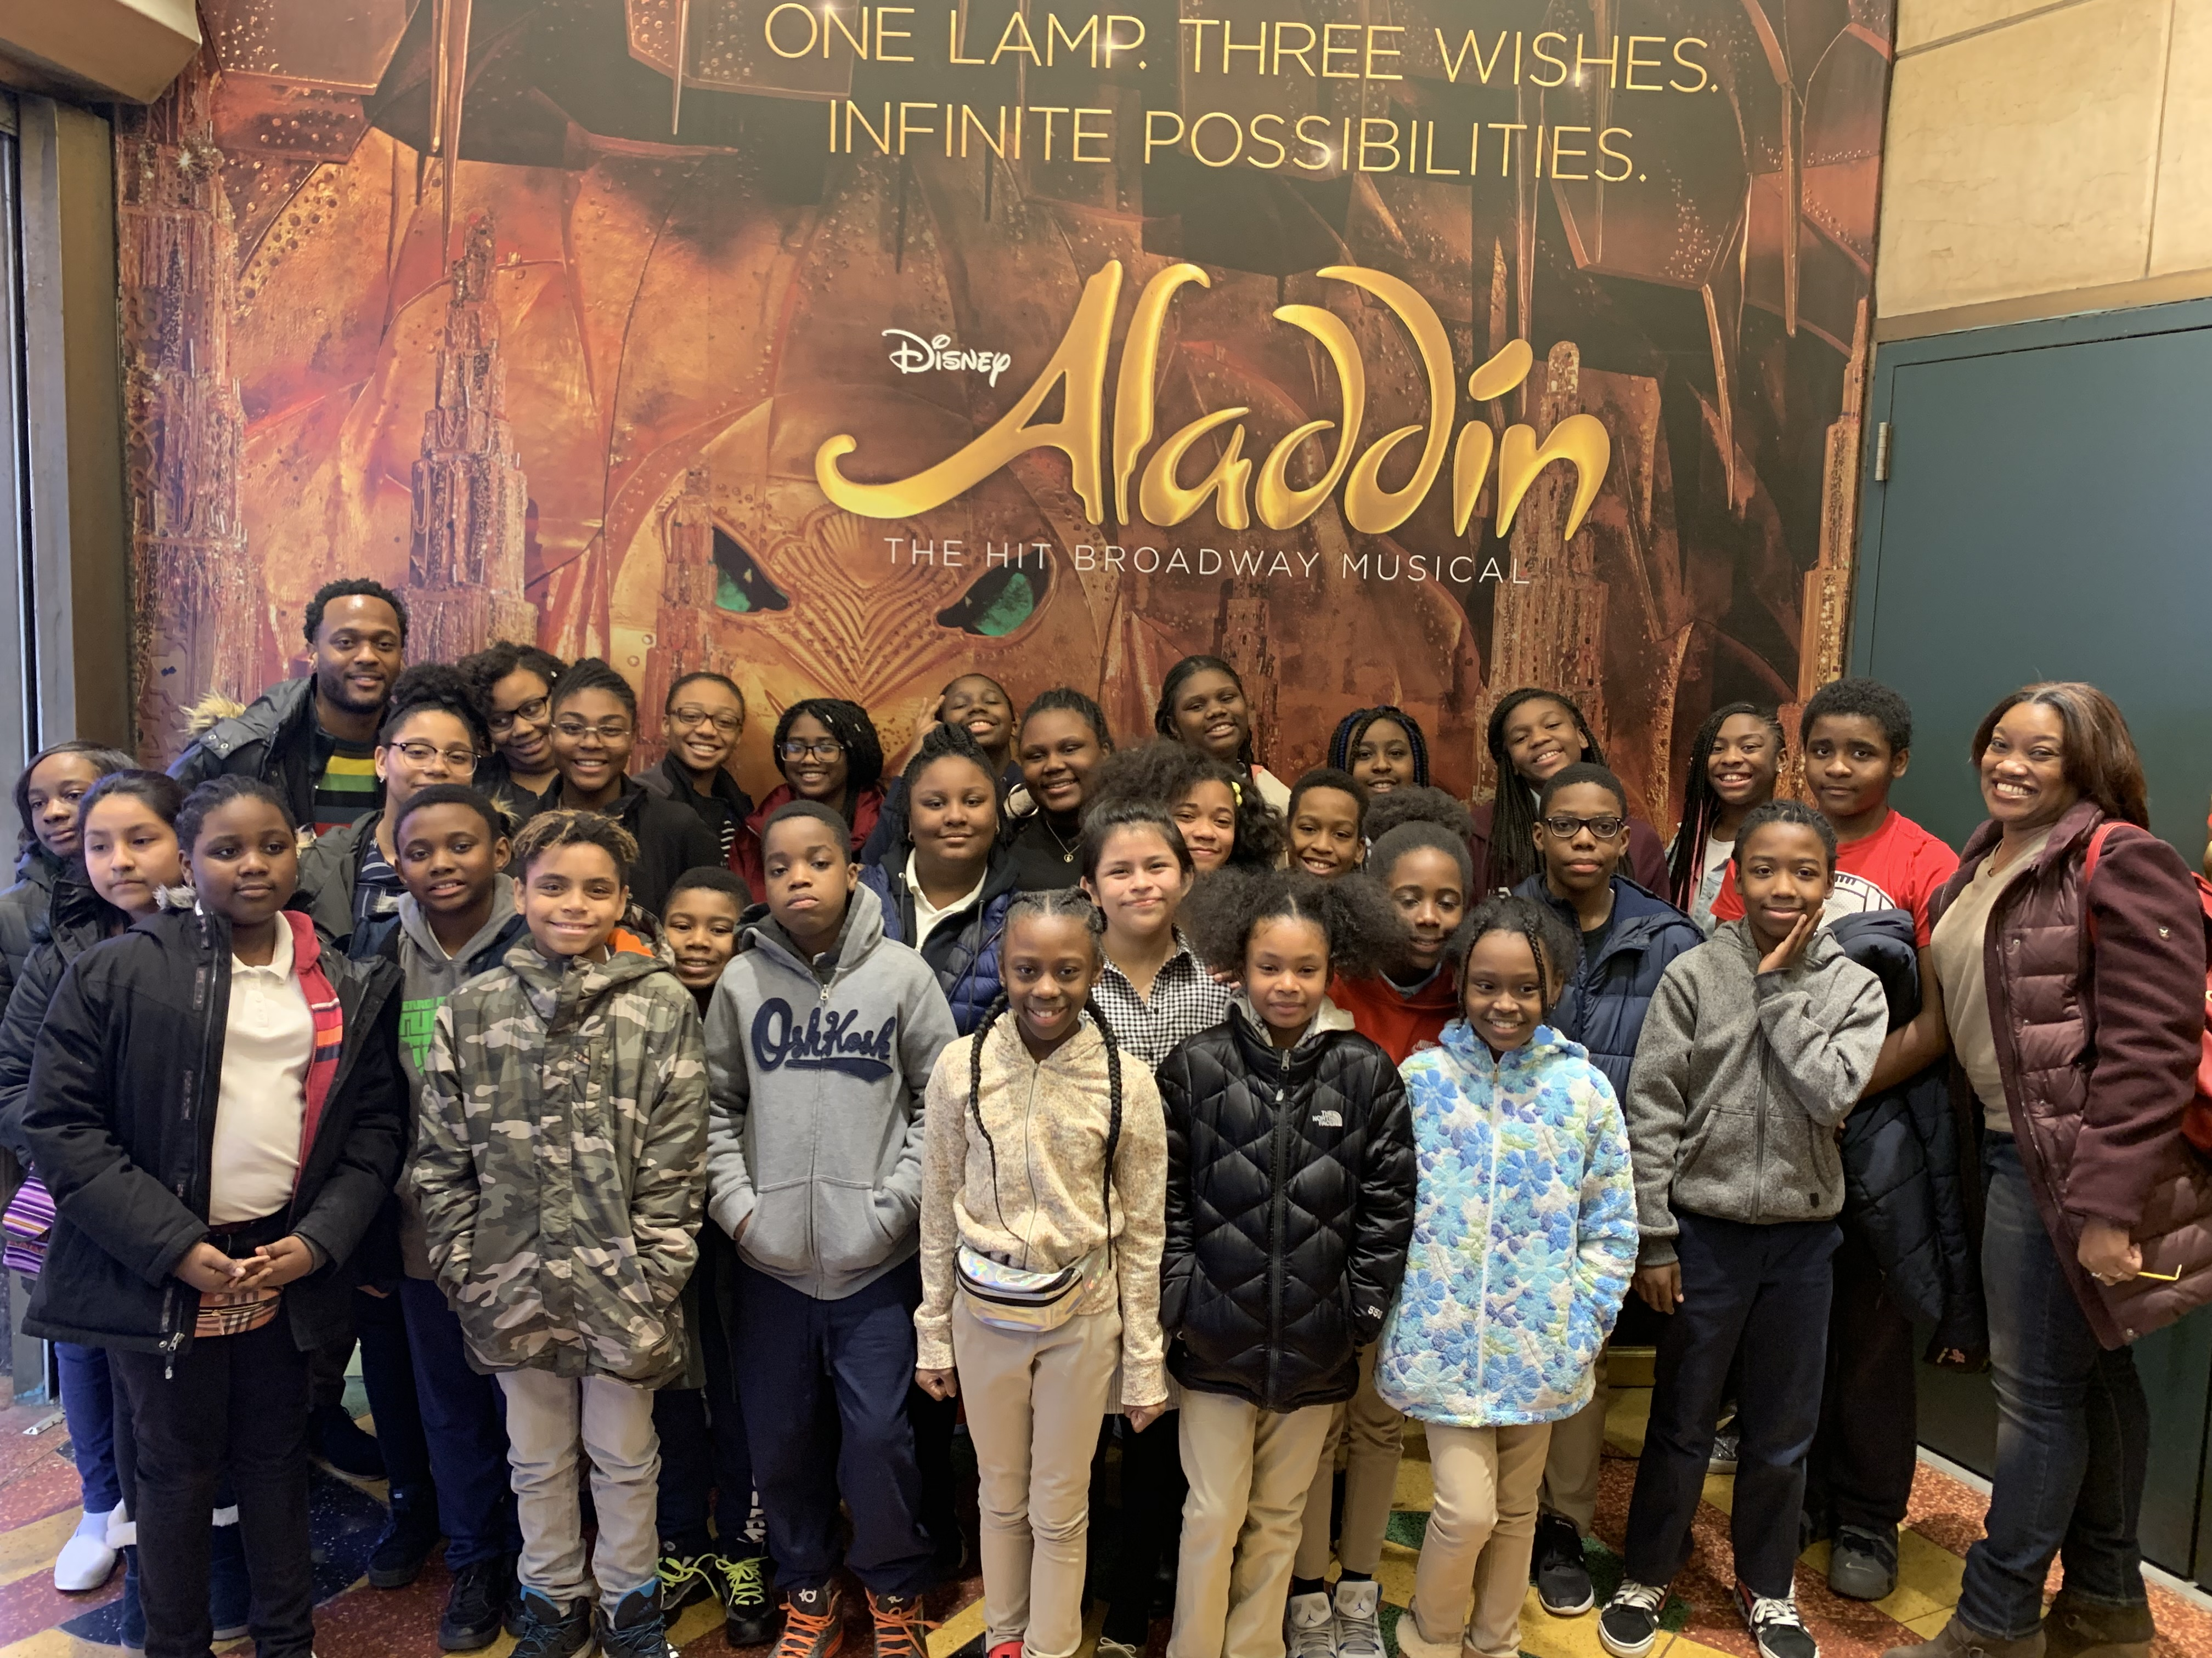
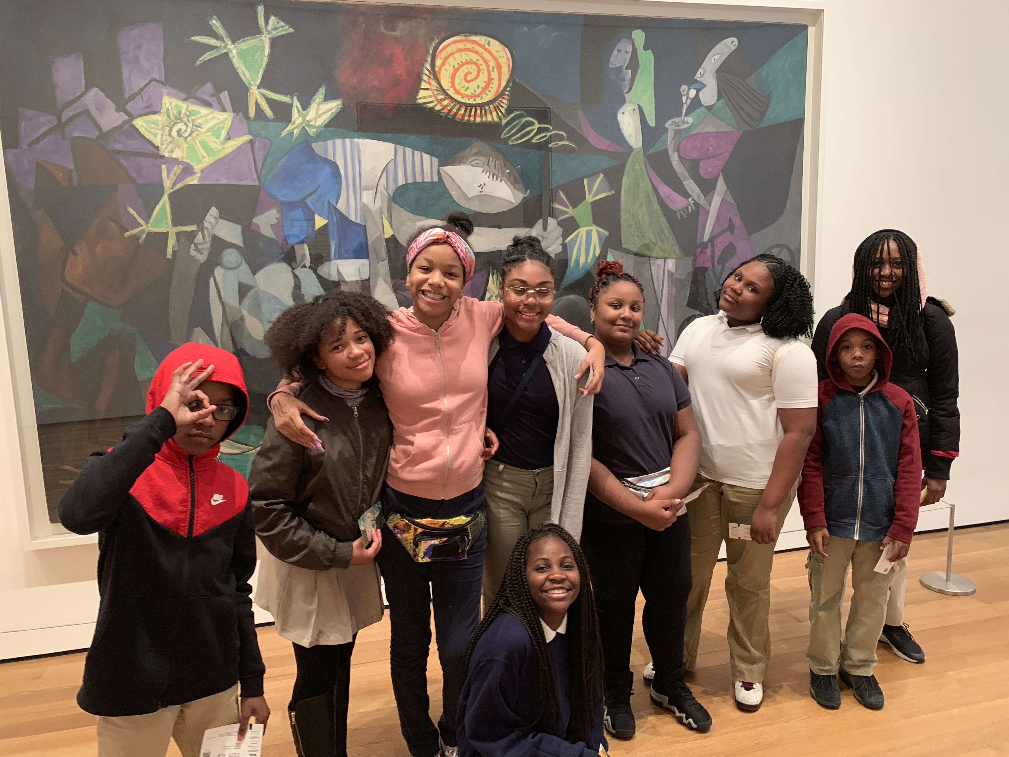
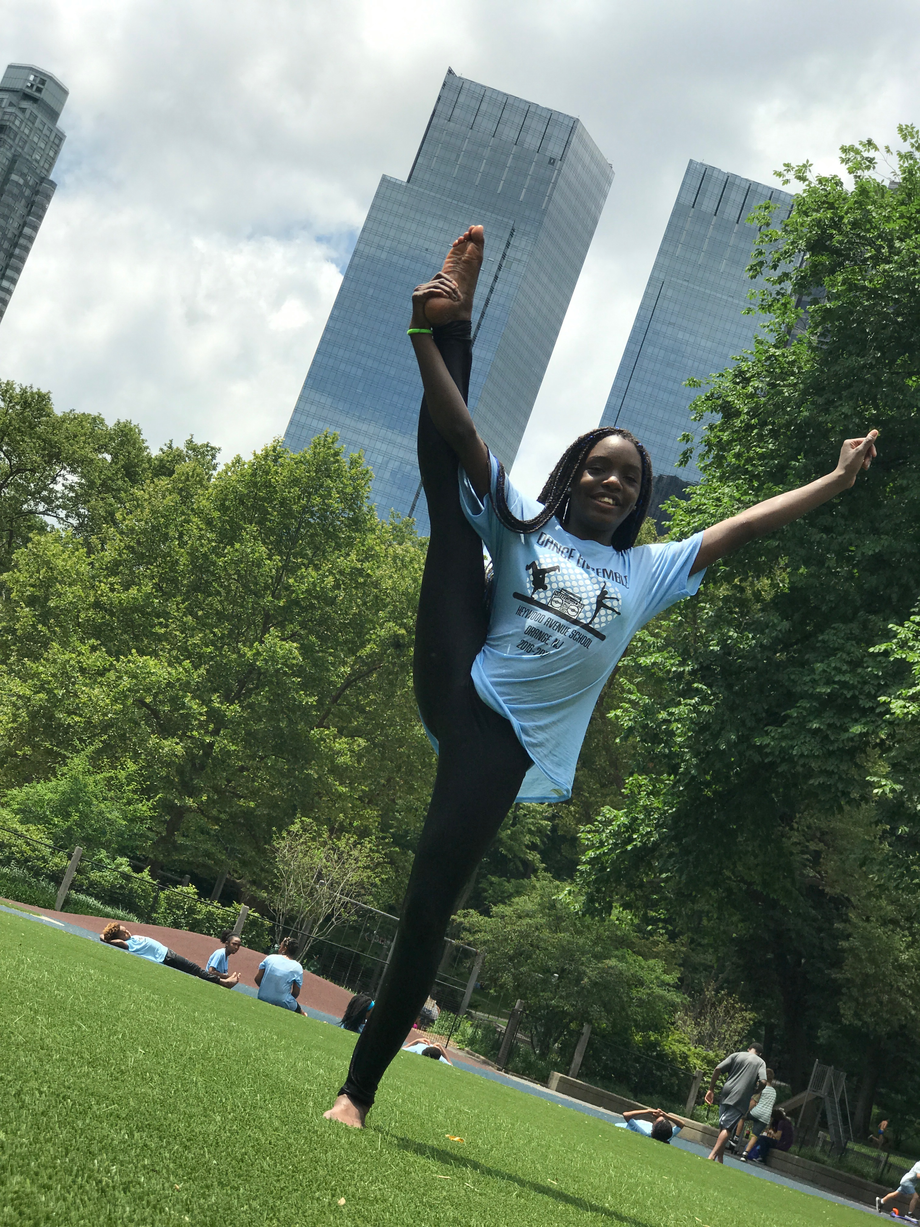
Welcome to Vocal Music

Welcome Back!
  - Heywood 20-21
  - School Year
Hello,  My name is Mr. McClain and I am so excited to be your vocal music teacher this year! We are going to have lots of fun, and we will learn a lot of different musical things this year. I hope you had a wonderful summer break and found time to refocus and energize yourselves for a great school year. I am super excited to meet you on the first day of school which begins on September 8, 2020. Want to know a little more about me? Below are some of a my favorite things!  About Mr. McClain  Favorite Things  Colors: Blue and Purple  Food: Nachos  Book: “Rich Dad, Poor Dad”  Hobbies: Traveling and singing  I Love: my family and my dog |  | San Juan, Puerto Rico- 2020  My Dog Jax

